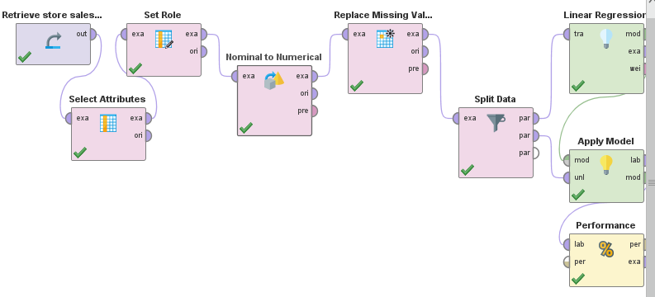
STORE SALES DATA ANALYSIS PROJECT IN RAPID MINER

DESCRIPTION
1. Retrieve Store Sales Data – importing the dataset into RapidMiner.
2. Select Attributes – choosing relevant features for analysis.
3. Set Role – assigning the target variable (label) for prediction.
4. Nominal to Numerical – converting categorical attributes into numeric form.
5. Replace Missing Values – handling missing data to make it suitable for modeling.
6. Split Data – dividing the dataset into training and testing sets.
7. Linear Regression – building a predictive regression model.
8. Apply Model – applying the trained model to test data.
9. Performance – evaluating the model using regression performance measures.

